Who is this permit for? Non-resident of Laguna Beach, age 65 years and older OR Military Veteran.
When is it valid? August 1, 2024 – July 31, 2025
How much does it cost? $200 Permits are prorated once on February 1, 2025 to $100

Permit Uses:
Permits allow for parking at eligible meters throughout the City without depositing payment into the meter.
- All City meters are eligible*
- Parking is limited to the maximum time indicated on the meter (3 hours, 2 hours, 1 hour, etc.)
  - *Exception: Permits not valid at meters on Laguna Canyon Road north of Forest Avenue and the adjacent Frontage Road during the summer festival season (Late June to Labor Day).
  - *Exception: Permits are always valid at meters adjacent to the dog park.

- Permits allow for parking at eligible City Pay Parking Lots without depositing payment into the ticket machine for up to 3 hours.

The following City Pay Parking Lots are eligible:

Lot 1 - 226 Broadway St.
Lot 2 - 322 Forest Ave.
Lot 3 - 225 Ocean Ave.
Lot 4 - 243 Ocean Ave.
Lot 5 - 348 Glenneyre St.
Lot 6 - 501 Glenneyre St.
Lots 7 & 8 - 30801 Coast Hwy
Lot 9 - 2154 Wesley Dr
Lot 13 - Susi Q/Comm. Center
(AFTER 5PM M-F & ALL DAY WEEKENDS)
Lot 22 - Aliso Beach
31131 Coast Hwy. (Up to 12 HRS)
*Lot 23 – LB Library 363 Glenneyre

- Exception: Permits are valid at Act V/ Lot 16 parking lot during summer festival season (Late June to Labor Day)
- Exception: Permits are NOT valid at Lot 12, this is an employee only parking lot.
- Exception: Permits are valid at Lots 10 & 11 only during non-summer season (Day after Labor Day to late June)
*Mon. –Thurs. AFTER 7:00p.m., Fri. & Sat. AFTER 5:00 p.m, All Day Sunday
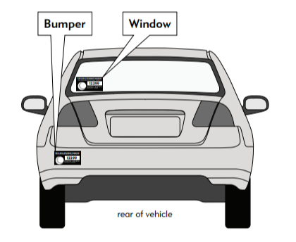
Permit Requirements:

Acceptable proof of age for the Senior Sticker include a

copy of Driver’s License or State ID Card.
Acceptable forms of identification for a Veteran include a current Uniformed Services ID card (active or retired) or a DD214 form.
- Each address is limited to a maximum of one Parking Permit.
- Addresses that are P.O. Boxes or commercial postal locations will not be accepted as an applicant’s address.
PLACE PERMIT ON LEFT REAR BUMPER
OR LOWER LEFT CORNER OF REAR WINDOW
MUST BE VISIBLE & ON OUTSIDE OF VEHICLE
Application Options:
Apply and purchase a Non-Resident Senior OR Veteran Parking Permit:
- In person at City Hall - 505 Forest Avenue, Laguna Beach, CA 92651
- Online at Parking Permits | Laguna Beach, CA (lagunabeachcity.net) (Required proof needs to be emailed)
- By mail, with payment check, application and a copy of required proof of age or Veteran status

