Who is this permit for? LBUSD residents living within the following three areas:

- Emerald Bay
- Newport Coast
- Laguna Audubon

When is it valid? August 1st, 2024 - July 31st, 2026
How much does it cost? Starting at $120
Permit Uses:
Permits allow for parking at eligible meters throughout the City without depositing the payment into the meter.
- All City meters are eligible*.
- Parking is limited to the maximum time indicated on the meter (3 hours, 2 hours, 1 hour, etc.)
  - Exception: Permits not valid at meters on Laguna Canyon Road north of Forest Avenue and the adjacent Frontage Road during the summer festival season (Late June to Labor Day).
  - Exception: Permits are always valid at meters adjacent to the dog park.

- Permits allow for parking at eligible City Pay Parking Lots without depositing payment into the ticket machine for up to 3 hours. The following City Pay Parking Lots are eligible:
Lot 1 - 226 Broadway St.
Lot 2 - 322 Forest Ave.
Lot 3 - 225 Ocean Ave.
Lot 4 - 243 Ocean Ave.
Lot 5 - 348 Glenneyre St.
Lot 6 - 501 Glenneyre St.
Lots 7 & 8 - 30801 Coast Hwy
Lot 9 - 2154 Wesley Dr.
Lot 13 - Susi Q/Comm. Center
(AFTER 5PM/ M-F & ALL DAY WEEKENDS)
Lot 22 - Aliso Beach
31131 Coast Hwy (Up to 12 HRS)
*Lot 23 – LB Library 363 Glenneyre

- Exception: Permits are valid at Act V/ Lot 16 parking lot during summer festival season (Late June to Labor Day)
  - Exception: Permits are NOT valid at Lot 12, this is an employee only parking lot.
  - Exception: Permits are valid at Lots 10 & 11 only during non-summer season (Day after Labor Day to late June)
*Mon. –Thurs. AFTER 7:00p.m., Fri. & Sat. AFTER 5:00 p.m, All Day Sunday
Permit Requirements:
Acceptable proof of residency for the name and address listed on the application are required.
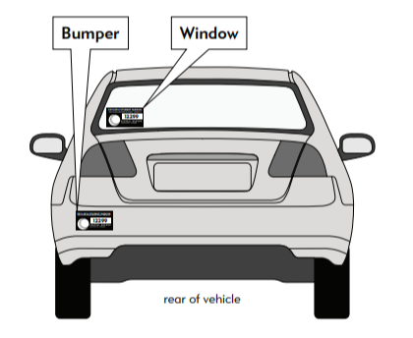
- DMV Registration
- Driver’s License/State ID Card
- Rental/Lease Agreement
- Utility Bill (gas, electric, water, or cable) showing name and service address
- Pre-printed check
- Addresses that are P.O. Boxes or commercial postal locations
will NOT be accepted.

Permit Cost:
PLACE PERMIT ON LEFT REAR BUMPER OR LOWER
LEFT CORNER OR REAR WINDOW
MUST BE VISIBLE & PLACE ON OUTSIDE OF VEHICLE
- $120 for the first permit at an address
- $150 for the second permit at an address
- Each address is limited to a maximum of TWO School District Parking Permits.
- Permits are prorated once on August 1, 2025.
- Fees are non-refundable, and permits are not transferable from one vehicle to another.
- Permits must be permanently affixed to the left rear bumper or the outside lower-left corner of the rear window.
Application Options:
- Online - www.lagunabeachcity.net
- Mail-in application – City of Laguna Beach Attn: Parking Permits, 505 Forest Avenue, Laguna Beach, CA 92651

